**Brain Tumors and Mental Health**

**Brain tumors can cause neurological and psychiatric symptoms in various ways:**

1. Structural Disruption: Tumors press on or invade specific brain regions.
2. Inflammation & Swelling: Cause chemical and electrical disruption.
3. Hormonal Imbalance: Especially relevant in pituitary tumors.
4. Immune & Stress Response: Can worsen psychiatric conditions.
5. Cognitive Decline: Memory, attention, and decision-making get impaired.

**Gliomas**

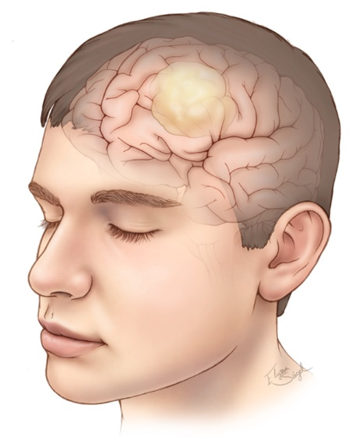

**Definition:**A glioma is a type of tumor that originates from glial cells, which support nerve cells in the brain.  
Gliomas can range from low-grade (slow-growing) to high-grade (aggressive). Examples include astrocytomas, oligodendrogliomas, and glioblastomas.

* **Depression and Mood Disorders**: Approximately 14% of glioma patients experience severe depressive symptoms, with tumor location influencing the severity of mood dysfunction. ​
* **Personality and Behavioral Changes**: Commonly reported symptoms include anger, loss of emotional control, indifference, and changes in behavior. These alterations can significantly impact social interactions and relationships. ​
* **Impact on Survival**: Depression in glioma patients has been linked to worsened survival outcomes, emphasizing the importance of addressing mental health in treatment plans. ​

**Scientific Backing**:

* Gathinji et al., 2024 (Nature): Found strong association between **tumor location** and **mood dysfunction**.
* Litofsky et al., Journal of Neuro-Oncology: Depression in glioma patients **significantly affects survival** and treatment compliance.
* [*PMC4467748*](https://www.ncbi.nlm.nih.gov/pmc/articles/PMC4467748): Discusses behavioral and cognitive deficits linked to tumor size and frontal lobe involvement.

**Meningiomas**

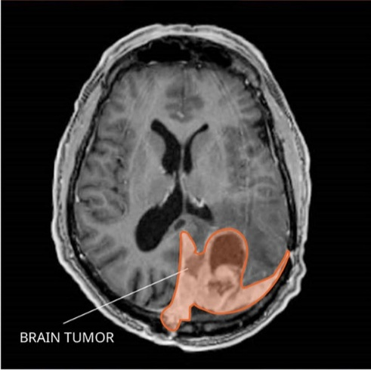

**Definition**: A meningioma is a tumor that arises from the meninges, the protective membranes covering the brain and spinal cord. Most meningiomas are benign and slow-growing, but their location can lead to significant symptoms.

* **Psychiatric Presentations**: Meningiomas can present with mood symptoms, psychosis, memory disturbances, personality changes, anxiety, or anorexia nervosa. ​
* **Depression and Anxiety**: Patients with meningiomas may experience significant mental health burdens, including depression and anxiety, both before and after surgical interventions. ​
* **Case Reports**: There are documented cases where meningiomas, particularly in the frontal lobe, have presented primarily with depressive episodes, highlighting the need for thorough neuroimaging in atypical psychiatric cases. ​

**Scientific Backing**:

* Chakrabarti et al., 2022: Patients often show psychiatric symptoms **before any neurological signs**.
* [*PMC8994241*](https://www.ncbi.nlm.nih.gov/pmc/articles/PMC8994241): Post-surgery recovery often shows **mental health improvements**, confirming the tumor’s role in behavioral changes.
* IP Innovative: Documents cases where frontal meningioma presented **primarily with psychiatric symptoms**.

**Pituitary Tumors**

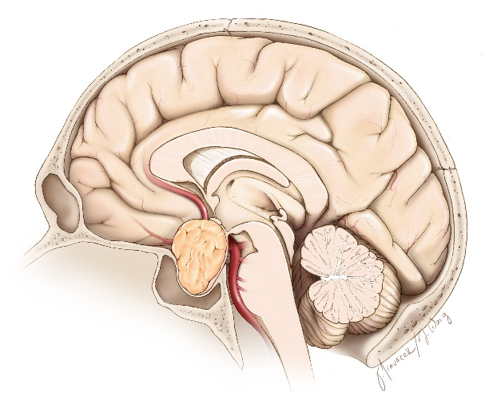

**Definition**: Pituitary tumors develop in the pituitary gland, a small organ at the brain's base responsible for hormone production. Most are benign adenomas but can disrupt hormonal balance and vision.

* **Hormonal Influence on Mood**: Pituitary tumors can disrupt hormonal balances, leading to mood disorders such as depression, anxiety, and apathy. These symptoms may result from the tumor itself or as side effects of treatment. ​
* **Prolactinomas and Depression**: Prolactin-secreting tumors (prolactinomas) have been associated with psychiatric symptoms, including depression and anxiety, due to elevated prolactin levels affecting neurotransmitter systems. ​
* **Cushing's Disease**: Pituitary adenomas causing Cushing's disease lead to excess cortisol production, which is linked to mood disturbances and cognitive impairments. ​

**Scientific Backing**:

* American Journal of Psychiatry: Pituitary tumor-induced hormonal fluctuations impact **dopamine and serotonin**, leading to psychiatric symptoms.
* PsychiatryOnline: Treatment of underlying tumor often **reverses mood issues**.
* [*ScienceDirect*](https://www.sciencedirect.com/science/article/abs/pii/S0163834313000157): Describes psychiatric manifestations in endocrine-related tumors.

**General Observations**

* **Behavioral and Personality Changes**: Brain tumors, depending on their location, can cause a range of behavioral changes, including irritability, impulsiveness, apathy, and emotional detachment. These changes can strain personal relationships and affect the patient's quality of life. ​[Tisch Brain Tumor Center](https://tischbraintumorcenter.duke.edu/blog/psychological-effects-of-brain-tumors?utm_source=chatgpt.com)
* **Importance of Early Detection**: In some cases, psychiatric symptoms may be the only manifestation of a brain tumor, underscoring the importance of considering neuroimaging in patients presenting with new or atypical psychiatric symptoms.